**Reflection /Reflective learning**

Reflection is a way of processing ideas that have no simple solution. In an academic context reflection is for a stated purpose. Moon (1999) likens reflection on learning to ‘*mental housekeeping’*

Try to think about something from your learning this year which has challenged you. Describe in one or two sentences what it was.

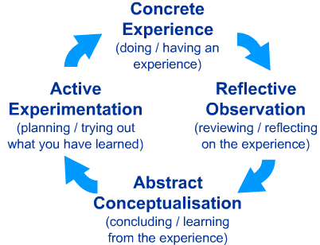

|  |  |
| --- | --- |
| **Reflective questions** | **Responses** |
| Who supported your learning? | The people in the group and Andy Brown the course leader. |
| What factors enabled you to learn? | The online webinar and working from work not having to travel to a classroom. |
| What have you remembered most from this experience? | I have had no experience from Project management so learning about it has been a great learning experience |
| What has this challenge enabled you to do now? | This challenge has given me the knowledge to look at certain tasks I couldn’t achieve before. |
| What did you do next? | To use the experience that I have learned and apply it in the work place. |
| What have you learned about yourself from this experience? | That I can achieve goals that I previously thought I couldn’t do. |

**Editing**

It is very important in reflective writing that you take time to edit your writing and make sure it is as concise as possible. Cut out as much description as possible.